**AZURE ACTIVE DIRECTORY**

**INTRODUCTION**

* We can create users, policies, roles, groups etc.
* Similar **IAM** service in **AWS.**
* **ADD Connect (To review)**

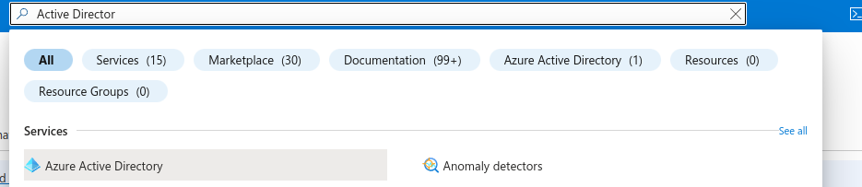

**1. Create users**

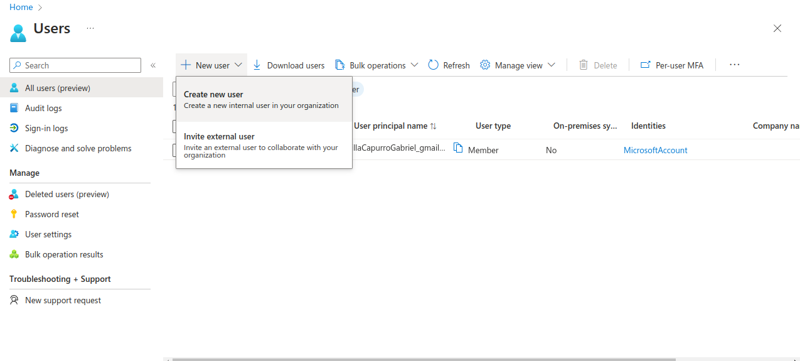

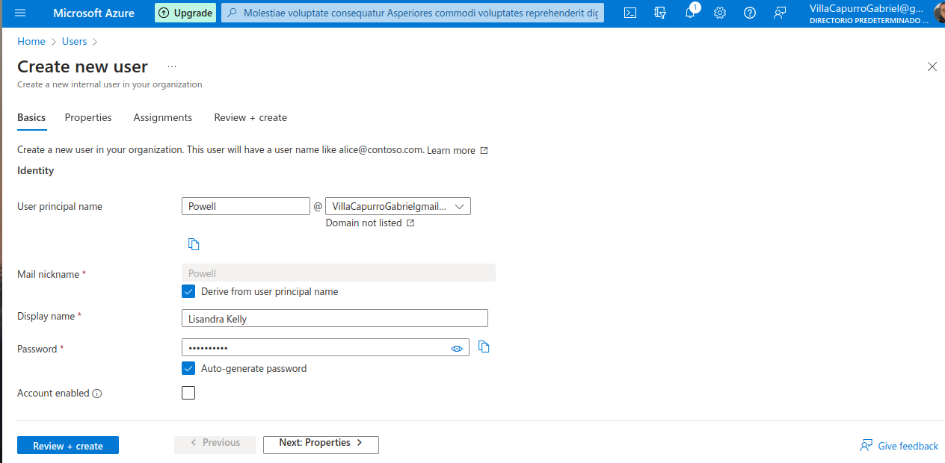

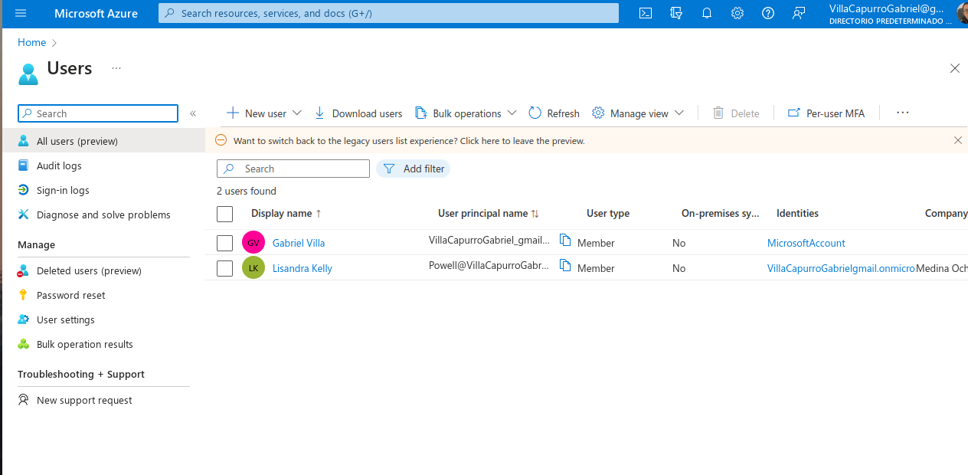

**2. Activity User**

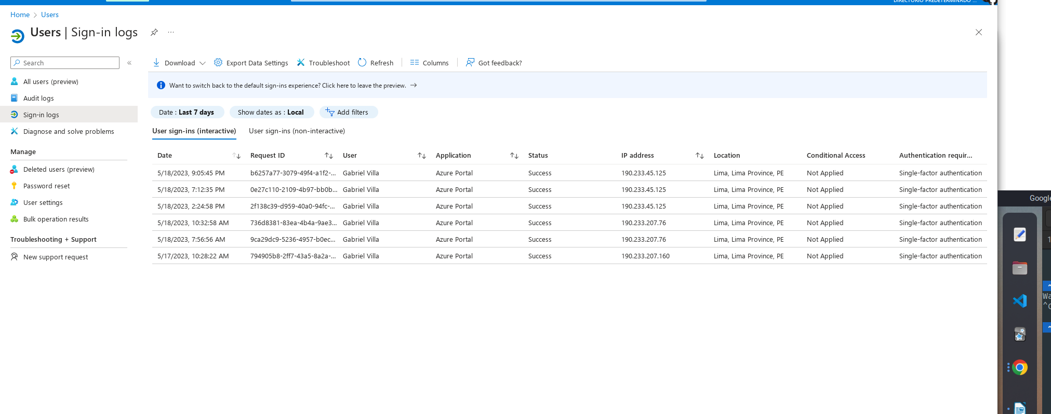

**3. Microsoft Support**

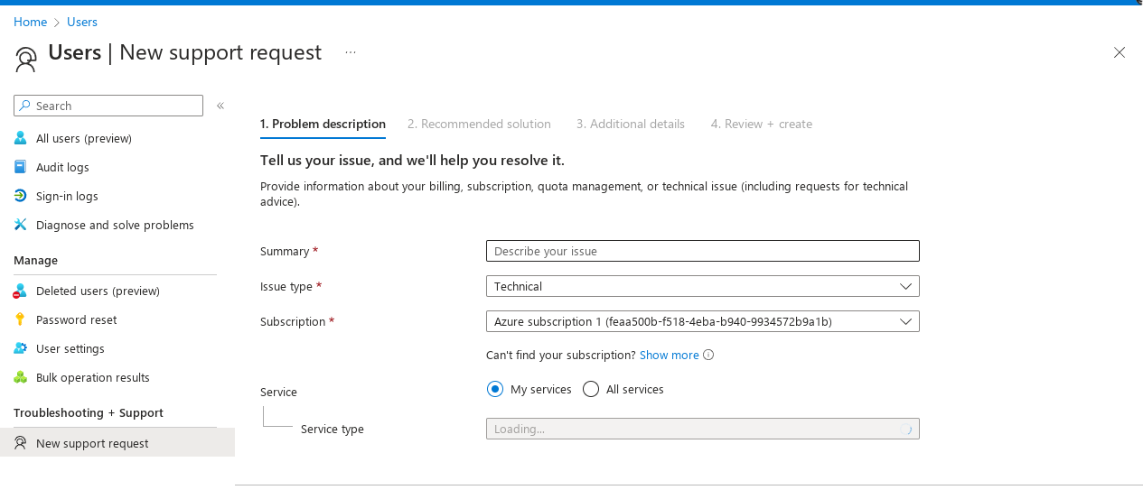

**4. Create a group**

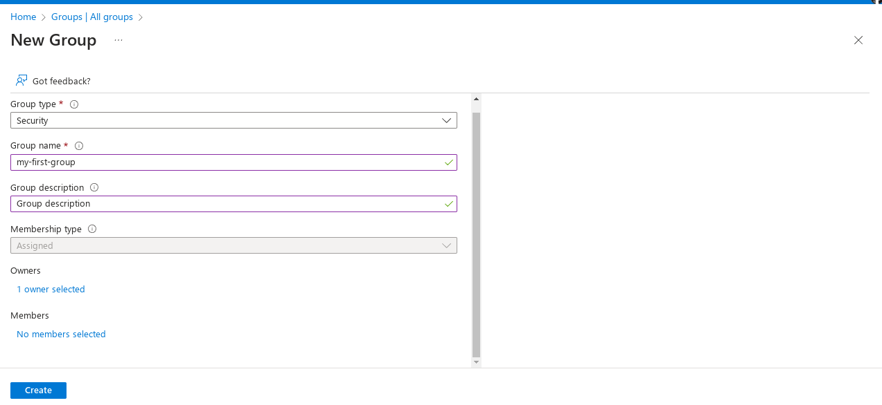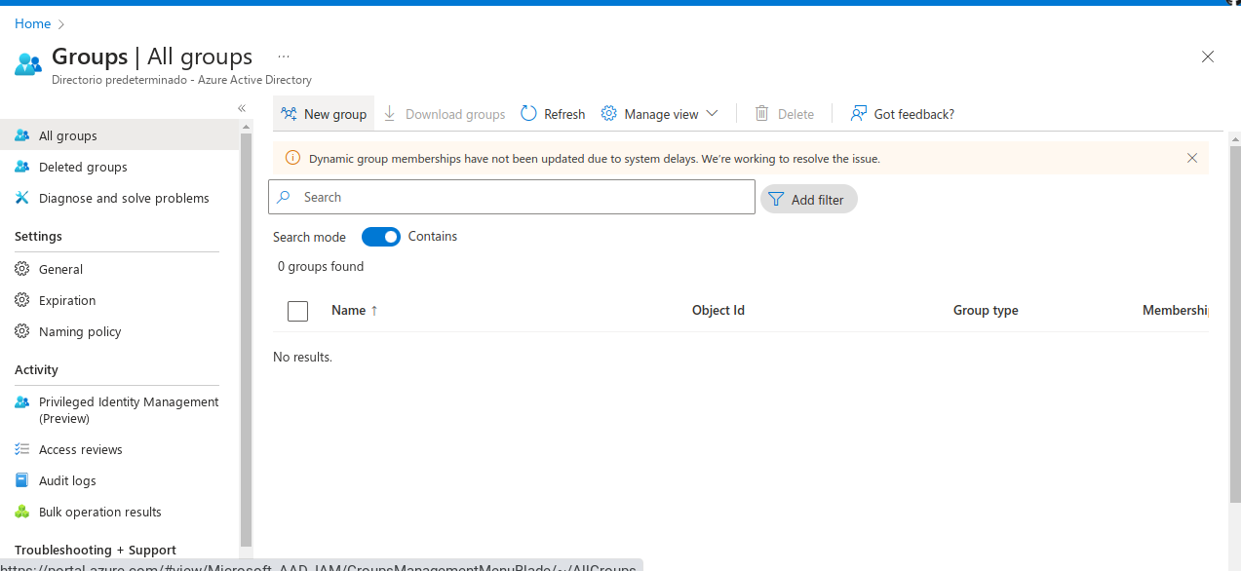

If we want to block some words:

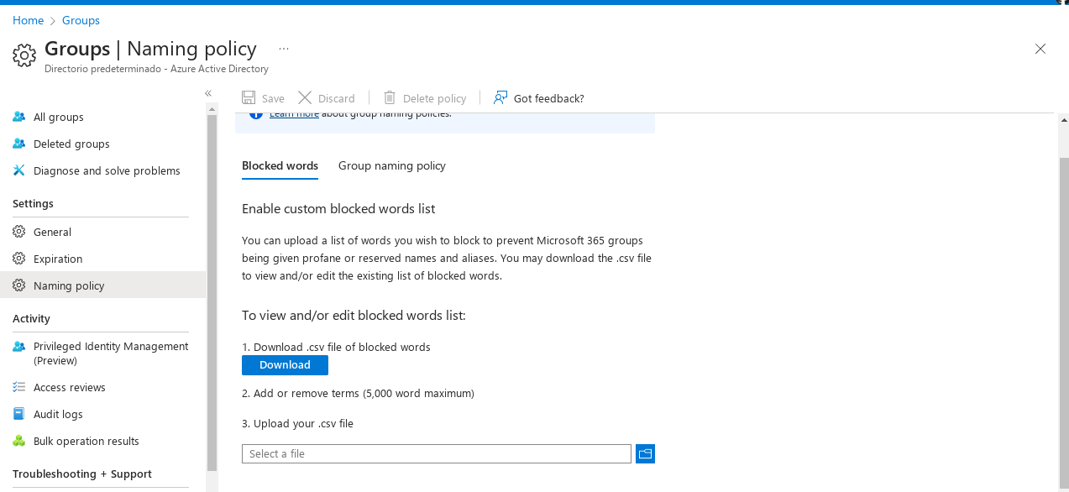

Or add prefix:

